Task 1: Open Instagram's home page in Chrome, right-click on a post image, and use Inspect Element to find the exact HTML tag and CSS class used for the image container. Write down the tag name and class.

- HTML Tag: div
CSS Class: _aagu
- HTML Tag: img
CSS Class: x21d xuf603 x1016tqk x1y x87ps6o xh8yej3

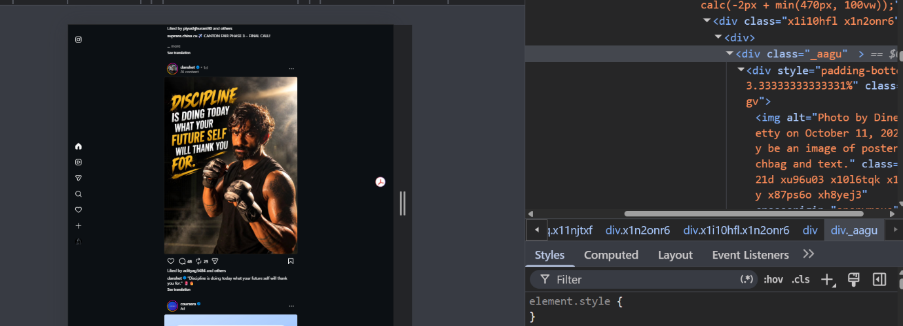
Task 2: Create a simple HTML file named myprofile.html that displays your name, a short bio, and a profile picture using appropriate HTML tags (h1, p, img). Open it in your browser and view the result.

Tasks 3: Use Chrome DevTools to change the background color of your name (in myprofile.html) to any color you like, live in the browser, without editing the HTML file.
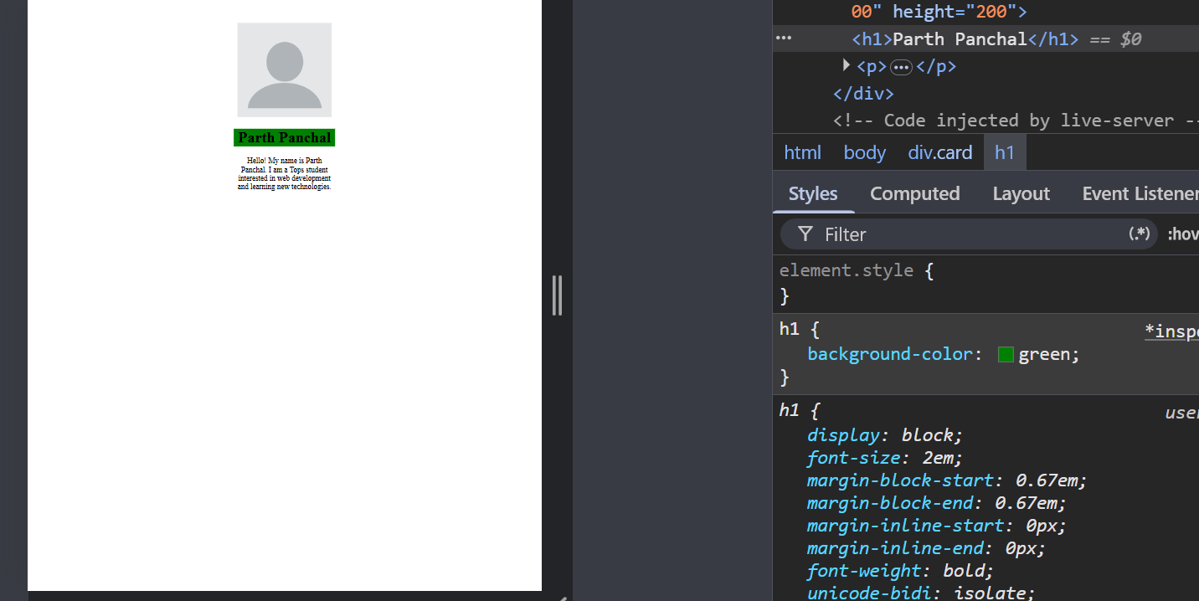
Task 4 : Draw a diagram or write a list showing the DOM structure (parent-child relationships) of your myprofile.html page. Include at least 3 levels (html > body > your content).

1. html
- head
  - title — My Profile
  - style
    - .card
- body
  - div — class="card"
    - img
      - src — Profile picture
      - alt — My Profile Picture
      - width — 200
      - height — 200
    - h1
      - Parth Panchal
    - p
      - Hello! My name is Parth Panchal. I am a Tops student interested in web development and learning new technologies.

